**Demo 4 - Hosting Your Own NuGet Feeds**

Some companies restrictwhich third-party libraries their developers may use. Therefore, they might not want developers to have access to everything in the official NuGet feed, or they might have a set of proprietary libraries they want to make available in addition to the official feed.

In these scenarios, you can set up a custom NuGet feed, and you can configure Visual Studio to offer that feed instead of or in addition to the official feed. A feed can be local (a folder on the local machine or a network folder) or remote (an internet URL).

**Creating Local Feeds**

Begin by creating or getting the packages you want to include in the custom feed and then putting them all into a folder. In the following example, a folder has been created in the local *c:* drive. The folder contains a single package (.nupkg file).

[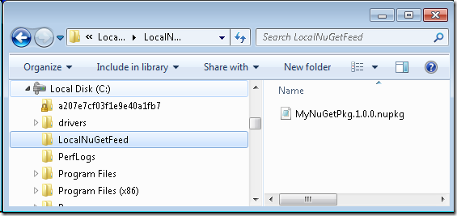](http://download.codeplex.com/Project/Download/FileDownload.aspx?ProjectName=nuget&DownloadId=189386)

Next, specify that folder as the location of a NuGet feed. In Visual Studio, from the **Tools** menu select **Library Package Manager** and then click **Package Manager Settings**.

[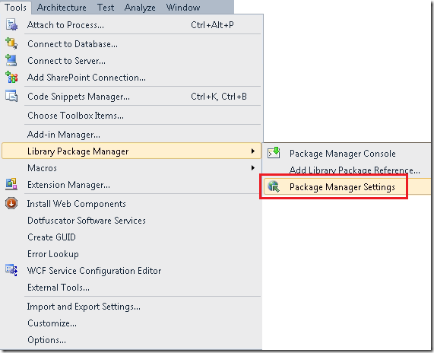](http://download.codeplex.com/Project/Download/FileDownload.aspx?ProjectName=nuget&DownloadId=189249)

The **Options** dialog box is displayed.

[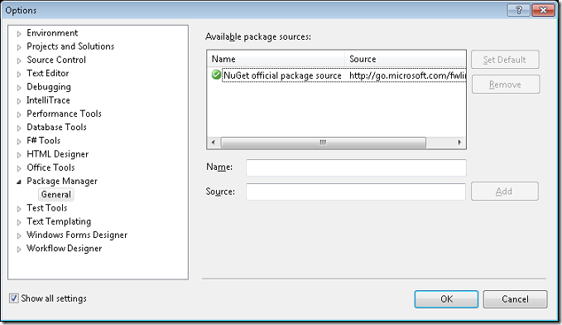](http://download.codeplex.com/Project/Download/FileDownload.aspx?ProjectName=nuget&DownloadId=189251)

In the **Name** box, enter a name for your feed. In the **Source** box enter the path of your packages folder.

[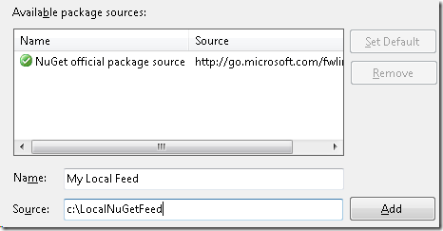](http://download.codeplex.com/Project/Download/FileDownload.aspx?ProjectName=nuget&DownloadId=189253)

Click **Add**. Your local folder is now another NuGet feed source.

[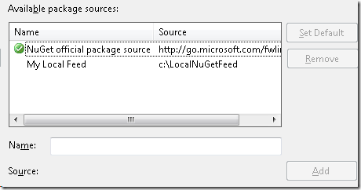](http://download.codeplex.com/Project/Download/FileDownload.aspx?ProjectName=nuget&DownloadId=189255)

To install a package using the new feed, in the **Package Manager Console** window, select the new feed in the **Package source** list.

[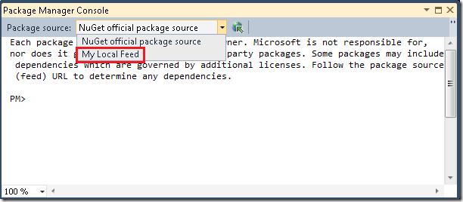](http://download.codeplex.com/Project/Download/FileDownload.aspx?ProjectName=nuget&DownloadId=189257)

You can also select the new feed in the **Online** tab of the **Add Library Package Reference** dialog box.

[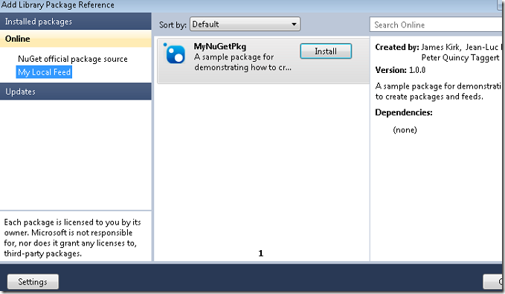](http://download.codeplex.com/Project/Download/FileDownload.aspx?ProjectName=nuget&DownloadId=189259)

**Creating Remote Feeds**

You can host a remote feed on a server the runs IIS.

Get the NuGet project named *Server* from [the NuGet Source Code page](http://nuget.codeplex.com/SourceControl/list/changesets). This is an [ASP.NET MVC 2](http://haacked.com/archive/2010/03/11/aspnet-mvc2-released.aspx) project. Deploy this project to an IIS server, place the packages you want to expose in the *~/Packages* folder, and remove the test projects from that folder.

To test the feed, press CTRL + F5 to run the website:

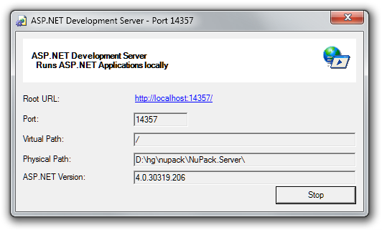

In the **Package Manager** options dialog box (**Tools** – **Library Package Manager** – **Package Manager Settings**), add the project URL to the feed.

[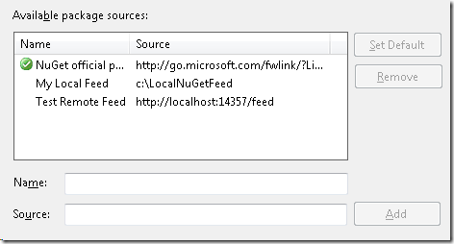](http://download.codeplex.com/Project/Download/FileDownload.aspx?ProjectName=nuget&DownloadId=189261)

You can then choose this feed in the **Package Manager Console** window and see the list of packages.

[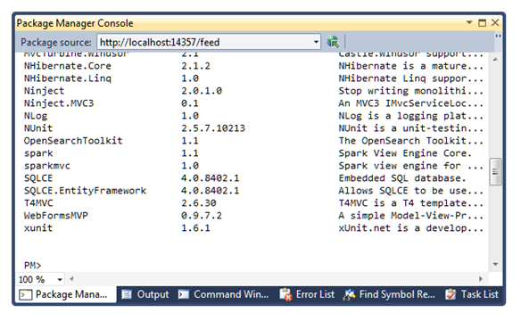](http://download.codeplex.com/Project/Download/FileDownload.aspx?ProjectName=nupack&DownloadId=159615)